22.May.2023
To,
Drug Controller General of India
Directorate General of Health and Family Welfare,
Government of India,
FDA Bhawan, ITO,
Kotla Road, New Delhi-110002

Sub: Certificate of Site with Detailed Raw Components for RT-PCR.
S. No. | Raw Components | Site
1.
2
3
4
5
6
7
8
9

Thanking you
Yours truly,
{manufacturerName}

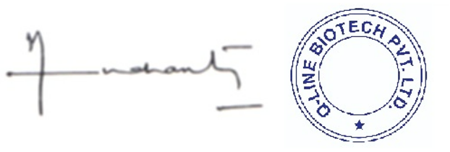
{directorName}
Director

